Hospital Data Analysis - Clustering

Setup
df <- df_origine %>%
filter(AGE > 60)

- Select only observations for patients over 60 years old.

Model 1 : Total costs, age and CCI

df_model1 <- df %>%
select(TOTAL_COST, CCI, AGE)

fviz_nbclust(df_model1, kmeans, method = "wss") + theme_classic()
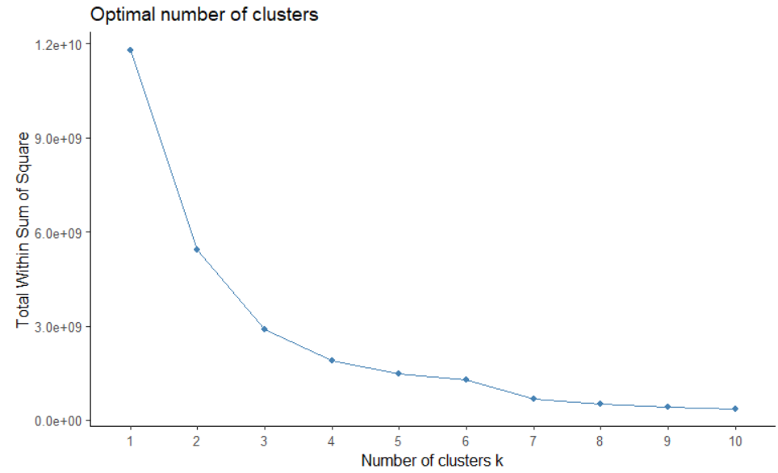
- The data partitioning method that has been chosen was that of the k-means (k-means clustering).
- The method used for estimating the optimal number of Clusters to specify when partitioning data with the k-means method is that of the WSS (Total Within cluster Sums of Squares).
- Based on the curve above, it is clear that we can observe the elbow “Number of clusters
k = 3”, meaning that 3 is then the optimal number of Clusters to retain.

mod1 <- kmeans(df_model1,
centers = 3,
nstart = 10,
iter.max = 200,
)

mod1

K-means clustering with 3 clusters of sizes 62, 1786, 678

Cluster means:
TOTAL_COST CCI AGE
1 12101.328 2.903226 77.93548
2 2025.263 2.593505 83.52352
3 4739.181 2.507375 81.53687

Clustering vector:
[1] 2 3 3 2 3 2 2 3 2 2 3 3 2 3 2 1 3 2 2 2 3 3 2 3 3 2 3 2 3 3 2 3 3 3 3 3 3 3 3 3 3 3 2 3 3 1 2
[48] 3 2 2 1 1 2 3 2 2 3 3 3 2 2 2 2 2 2 2 2 2 3 2 2 3 3 2 2 3 2 3 2 2 2 2 2 2 2 3 2 2 2 2 2 2 3 2
[95] 2 2 2 2 2 2 2 2 3 2 2 3 2 2 2 2 2 2 2 2 2 2 2 2 2 2 3 2 2 2 2 2 3 2 2 2 2 3 2 3 2 2 2 2 2 2 3
[142] 2 2 3 2 2 2 2 3 3 3 2 3 2 2 2 2 2 2 2 2 2 1 2 3 2 2 3 2 2 3 3 3 2 3 2 2 3 3 2 2 2 2 3 2 3 3 3
[189] 3 2 3 2 3 2 3 3 2 2 2 2 2 2 2 3 2 2 3 2 3 3 3 3 3 3 3 2 2 3 3 3 1 2 2 3 2 3 3 3 2 2 3 2 2 2 1
[236] 2 3 1 2 3 2 3 3 1 2 2 2 2 2 2 3 2 2 3 2 2 2 3 2 2 2 2 2 2 2 2 2 3 2 3 3 2 2 2 2 3 2 2 2 2 3 3
[283] 1 2 1 3 3 1 2 2 2 2 2 2 2 3 3 2 3 3 3 2 3 3 2 3 2 3 1 3 3 3 2 3 1 2 2 2 2 2 2 2 3 2 2 2 3 2 2
[330] 3 3 2 2 3 2 2 2 1 3 2 3 3 2 3 3 3 3 3 2 2 2 2 1 2 2 2 2 2 2 2 3 2 2 1 1 1 2 2 3 2 2 3 1 1 3 3
[377] 3 3 2 3 3 1 1 2 2 2 2 2 2 2 2 3 3 3 2 1 3 3 3 2 2 3 1 1 2 2 2 2 3 3 2 3 3 2 2 2 2 2 2 3 2 2 3
[424] 3 2 2 3 2 3 3 3 3 2 2 2 2 3 3 3 3 2 2 2 2 2 2 2 3 2 2 2 2 2 2 2 2 2 2 2 3 3 2 3 2 2 3 3 2 2 3
[471] 2 2 2 2 2 2 3 2 2 2 3 2 2 3 2 2 2 2 2 2 2 3 2 2 2 2 2 2 2 2 2 2 3 2 3 2 2 2 2 2 3 2 2 2 3 3 2
[518] 2 3 3 3 2 2 2 2 1 2 3 2 3 1 2 3 3 2 2 3 2 3 3 3 2 3 3 3 3 3 2 2 3 3 3 3 2 3 2 3 2 2 3 3 3 3 3
[565] 1 1 3 2 3 1 1 2 2 3 3 3 2 3 3 2 3 3 3 3 3 3 3 1 3 3 3 3 3 3 3 3 2 2 2 2 3 3 1 3 1 3 1 2 2 2 3
[612] 2 3 3 2 2 3 3 3 3 3 3 3 3 3 2 3 3 1 3 3 1 1 3 3 3 2 1 1 2 2 2 2 3 3 2 3 2 2 2 3 2 3 3 2 2 2 2
[659] 2 3 2 2 2 2 2 2 2 3 2 2 2 3 2 3 2 3 2 2 2 2 3 2 2 3 2 2 3 3 3 3 3 2 2 2 3 2 2 3 3 2 3 3 2 3 2
[706] 3 3 3 2 2 2 2 2 3 2 2 2 2 2 2 2 2 3 2 2 1 2 2 2 2 3 2 2 2 2 2 3 3 3 2 2 3 2 2 3 2 2 2 2 3 2 3
[753] 2 2 3 3 2 3 2 2 3 2 2 2 2 3 2 2 2 2 3 2 2 2 2 2 2 3 2 3 2 3 2 2 2 3 2 3 2 3 2 3 2 2 2 3 2 2 3
[800] 2 2 2 2 3 2 2 2 3 2 2 2 2 2 2 2 2 2 3 2 3 2 2 2 2 2 2 2 2 2 2 2 2 2 2 2 2 2 2 2 2 3 2 2 2 2 3
[847] 2 2 2 2 2 2 3 2 2 2 2 2 3 2 3 2 2 3 2 3 3 3 2 2 2 2 2 2 2 2 3 2 2 2 2 2 3 2 3 3 3 3 2 3 2 2 2
[894] 2 3 2 2 2 2 2 3 3 2 2 2 2 2 2 2 2 2 2 2 2 1 2 2 2 2 2 2 3 2 3 2 2 2 2 2 2 2 2 2 3 3 2 2 2 2 2
[941] 2 3 2 2 2 2 2 2 2 2 2 2 2 3 2 2 2 2 2 2 2 2 2 2 3 2 2 2 2 2 3 2 2 3 2 3 3 2 2 2 2 2 3 2 2 3 2
[988] 3 2 2 3 2 2 3 2 2 3 3 2 2
[ reached getOption("max.print") -- omitted 1526 entries ]

Within cluster sum of squares by cluster:
[1] 962615839 1032147453 904193493
(between_SS / total_SS = 75.4 %)

Available components:

[1] "cluster" "centers" "totss" "withinss" "tot.withinss" "betweenss"
[7] "size" "iter" "ifault"

- The number of observations for each of the 3 clusters will be respectively: 62, 1786 and 678 observations.
- Les coordinates (TOTAL_COST, CCI, AGE) of each Centroid (position of the Cluster’s center) of each Cluster are as follow:
- Centroid of Cluster 1 : (12101.328, 2.903226, 77.93548) ;
- Centroid of Cluster 2 : (2025.263, 2.593505, 83.52352) ;
- Centroid of Cluster 3 : (4739.181, 2.507375, 81.53687).
- Based on the Clustering Vector above, we can consult the Cluster of membership of each line of observations on admissions by consulting just the cluster number which represents the line of observations on the position of the latter in the vector: line 1 belongs to Cluster 2, line 2 belongs to Cluster 3, line 988 belongs to Cluster 3…
- The Sum of the squares of the distances of the points of a Cluster to their Centroid for each of the Clusters 1, 2 and 3 are respectively: 962 615 839, 1 032 147 453 and 904 193 493. From these values, we can deduce that Cluster 3 is the most compact of all, followed by Cluster 1 and finally, Cluster 2 is the least compact of all.
- The ratio “between_SS / total_SS = 75.4” can tell us that we have a relatively good Clustering here.
Residuals :
res.mod1 <- df %>%
mutate(groupe= paste0('G',mod1$cluster))

- We have named our Clusters 1, 2 and 3 respectively by « G1 », « G2 » and « G3 ».
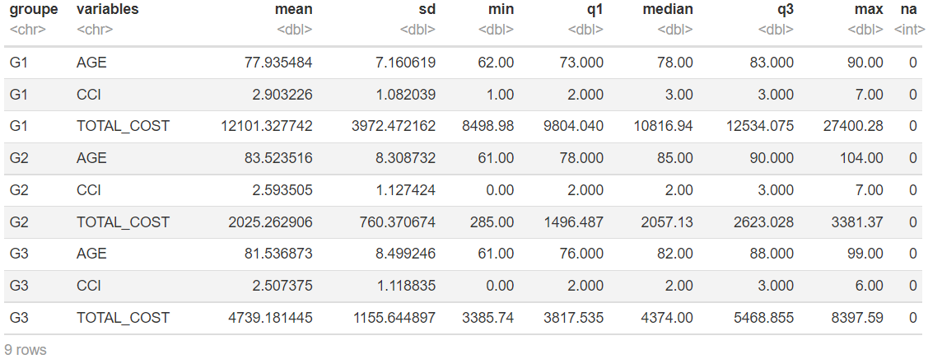
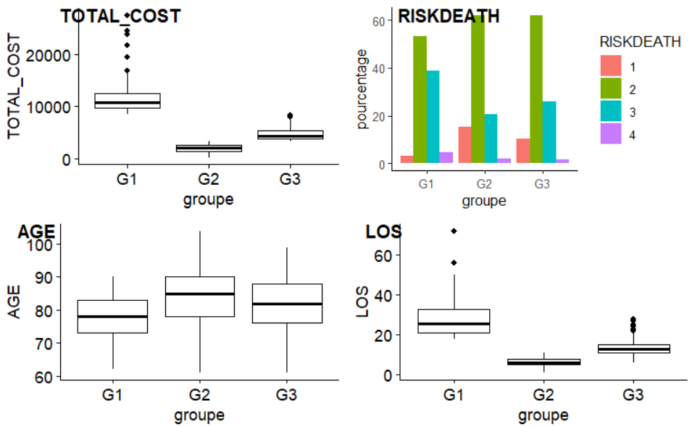
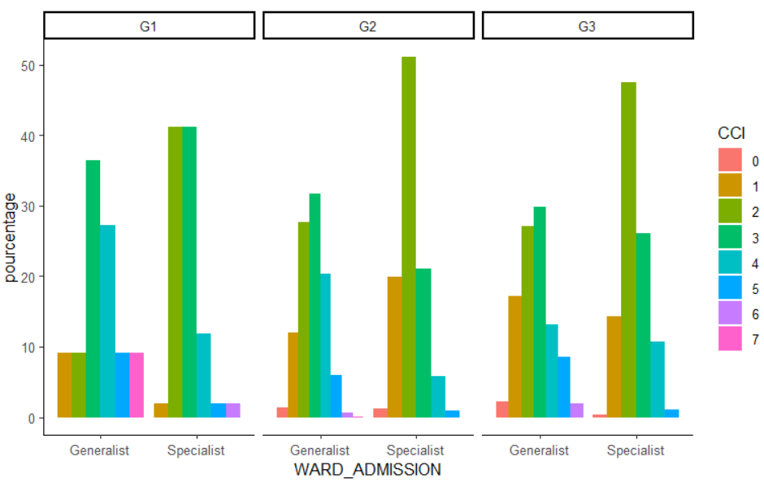

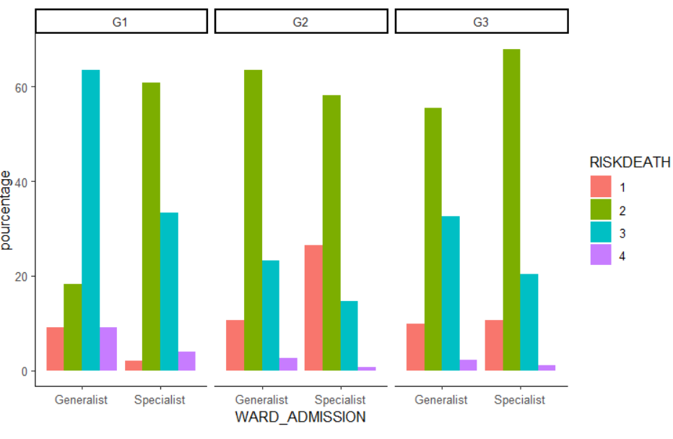
- We can notice that for the case of the TOTAL_COST :
- The highest values are found within G1, with also the greatest variability of data characterized by an asymmetric distribution;
- The lowest values are clearly found within G2, with also the smallest of the data variability;
- The group G3 corresponds to higher values than those observed in G2, with a slightly greater data variability and more or less asymmetrical in terms of data distribution;
- Outliers are observed the most in G1 and much less in G3. They are literally missing in G2.
- For the case of the RISK_DEATH :
- The peaks of proportions all correspond to the admissions with a RISK_DEATH level of 2 within the 3 groups, peaks that are more important in G2 and G3 than in G1;
- The RISK_DEATH level 3 is more frequent for the case of admissions in G1, it is slightly less for those in G3, and much less for those in G2;
- The RISK_DEATH level 1 is more frequent for the case of admissions in G2, slightly less for those in G3 and relatively rare for those in G1;
- The RISK_DEATH level 4 remains relatively rare in the three groups, however, it is mainly found in G1.
- For the case of the AGE:
- The admissions corresponding to the oldest ages concern the most the group G2, then G3 and slightly less G1.
- The variability is quite significant in each group, and the data distribution is relatively symmetrical in each group.
- For the case of the LOS:
- The highest values of LOS are (very) mainly found within G1, whereas the lowest ones are found in G2;
- The variability is largely less significant in G2 and G3, but more significant in G1;
- Outliers are found in G1 and G3
- For the case of the CCI per WARD_ADMISSION:
- We can notice that the proportions of admissions with a CCI 2 constitute the peaks for the case of all the Specialist Wards of each group. The peaks are more significant in G2 (around 50%) and G3 than in G1;
- The peaks for the case of the Generalist Wards are made up of the proportions of admissions with a CCI 3, more significant in G1, then in G2 and finally less significant in G3;
- CCIs 7 are particularly frequent for the case of admissions in G1:Generalist Wards, and rare, even non-existent within the other Wards of any Group;
- CCIs 4 are always more or less frequent for the case of admissions, both in Specialist and Generalist Wards, in all the Groups (more frequent in G1: Generalist Wards)
- For the case of the RISK_DEATH per WARD_ADMISSION:
- Except the particular case of G1:Generalist Wards, whose peak of proportions in terms of admissions corresponds (obviously) to the RISK_DEATH level 3, all the peaks of proportions correspond to the Level 2 in all the other Wards of any group (a level, however, less observed for the case of admissions in G1:Generalist Wards) ;
- Except the case of G1:Specialist Wards, the level 1 seems to be similarly frequent in the Generalist Wards of each group. For the case of the Specialist Wards, this level 1 is particularly more frequent in G2, and less frequent in G3 and G1;
- By performing our reading from G1 to G3, we can notice that the frequencies of the level 4 are decreasing in the Generalist Wards, with just smaller proportions than in the Generalist Wards.

Model 2 : Total costs, age and CCI – normal distribution

df_model2 <- df %>%
select(TOTAL_COST, CCI, AGE) %>%
scale()
fviz_nbclust(df_model2, kmeans, method = "silhouette")

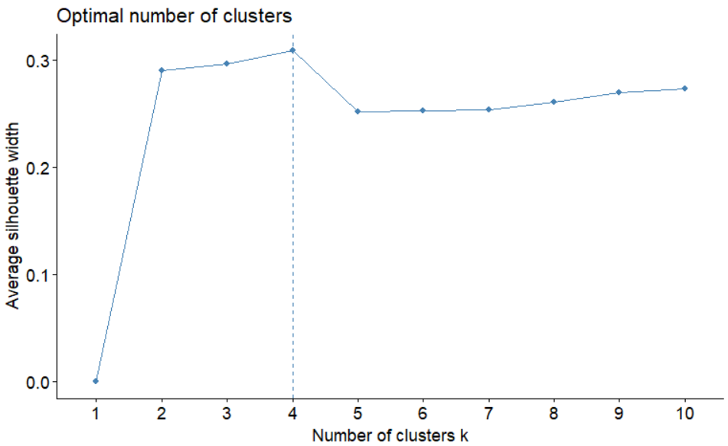
- The data partitioning method that has been chosen was that of the k-means (k-means clustering).
- The method used for estimating the optimal number of Clusters to specify when partitioning data with the k-means method is that of the Average Silhouette Width.
- Based on the curve above, it is clear that we have a maximum value of the Average Silhouette width with 4 clusters, which means that 4 is then the optimal number of Clusters to be kept.

mod2_nc <- 4

mod2 <- kmeans(df_model2,
centers = mod2_nc,
nstart = 10,
iter.max = 200,
)

mod2
K-means clustering with 4 clusters of sizes 974, 674, 745, 133

Cluster means:
TOTAL_COST CCI AGE
1 -0.19878202 0.9241646 0.5033786
2 -0.04451713 -0.4516112 -1.2275418
3 -0.23052149 -0.8272487 0.5551044
4 2.97260711 0.1545108 -0.5750399

Clustering vector:
[1] 2 3 3 1 2 2 3 4 2 2 2 3 3 1 3 4 3 2 2 3 2 3 2 1 3 2 4 3 2 2 3 2 4 2 4 2 3 2 2 3 2 3 1 2 2 4 2
[48] 2 2 1 4 4 3 1 3 3 3 2 2 2 2 2 2 3 3 1 2 1 3 3 3 2 1 2 3 2 3 3 2 2 3 2 2 3 3 3 3 3 1 3 2 3 3 2
[95] 3 3 2 1 3 3 2 2 2 3 3 2 3 3 3 3 2 3 2 3 3 2 3 3 2 2 2 3 3 2 3 3 3 2 2 2 3 2 1 2 1 3 3 2 3 2 4
[142] 2 2 2 2 2 2 2 1 3 3 2 2 2 2 3 3 3 3 2 3 3 4 3 2 3 2 4 2 3 3 1 2 3 2 3 3 2 3 2 3 3 3 2 1 2 2 3
[189] 1 3 3 3 3 3 3 2 2 3 3 2 3 3 3 2 2 3 4 1 1 2 1 4 1 1 2 2 1 2 2 2 4 2 1 2 2 2 3 2 3 3 2 3 2 2 4
[236] 3 3 4 3 2 2 3 3 4 3 3 2 3 3 3 1 2 3 1 3 3 3 2 1 3 2 2 3 2 3 2 1 1 2 2 3 3 3 2 3 3 3 3 3 3 2 3
[283] 4 3 4 1 1 4 2 1 3 3 2 3 2 3 4 2 2 2 2 2 4 2 1 2 1 2 4 1 4 1 1 1 4 1 2 2 2 3 2 3 1 3 2 1 3 2 3
[330] 1 2 3 2 1 1 1 1 4 3 3 1 2 3 2 2 2 4 3 1 2 3 1 4 1 2 1 1 2 1 1 1 3 1 4 4 4 2 1 3 1 1 1 4 4 4 4
[377] 4 2 1 3 2 4 4 2 1 1 3 3 3 1 2 1 4 2 2 4 2 1 1 1 2 1 4 4 2 1 1 2 4 1 1 2 1 3 1 1 3 1 1 1 1 2 3
[424] 4 1 1 1 1 1 2 1 1 2 1 3 3 1 1 2 2 3 3 1 3 1 1 1 3 3 2 2 3 2 2 1 1 2 3 3 4 1 3 2 3 3 1 1 1 1 4
[471] 3 3 3 2 3 1 3 3 3 3 3 2 2 1 1 1 2 2 1 2 3 1 1 1 1 2 1 1 3 1 2 3 1 3 2 1 1 1 1 2 1 1 2 3 1 3 1
[518] 3 3 3 1 2 2 1 1 4 2 1 2 2 4 3 4 1 3 3 1 1 2 3 2 3 2 4 2 4 2 1 3 2 2 4 3 2 4 1 2 1 2 4 2 2 3 2
[565] 4 4 2 2 2 4 4 2 2 3 1 4 3 3 2 2 3 2 2 1 2 1 2 4 4 2 2 1 1 2 4 1 3 1 2 2 1 1 4 2 4 4 4 1 2 3 1
[612] 1 2 4 3 2 4 2 4 2 2 3 2 2 2 2 4 2 4 4 4 4 4 4 2 2 2 4 4 2 2 3 3 3 3 3 1 2 2 3 1 1 3 3 2 1 3 3
[659] 1 1 1 1 1 2 3 1 3 2 1 1 1 3 1 3 3 1 2 2 3 2 2 3 1 1 3 1 1 3 2 3 4 1 2 2 1 2 1 1 1 2 2 3 1 1 3
[706] 1 2 3 2 3 1 1 1 1 1 1 3 1 1 3 3 3 1 2 1 4 1 3 3 1 3 3 1 1 2 1 3 3 3 1 2 1 1 1 3 2 1 3 1 1 2 3
[753] 3 1 1 3 1 2 1 2 4 3 3 1 1 2 2 3 1 1 4 3 1 1 2 1 2 2 1 4 1 1 1 3 1 2 1 3 1 3 1 3 1 3 3 4 1 1 2
[800] 1 3 3 3 1 3 1 1 2 1 3 3 1 2 2 3 2 3 2 3 4 2 3 1 1 2 3 3 1 3 1 3 1 1 1 1 2 3 2 1 1 1 2 1 3 1 3
[847] 2 1 3 1 1 2 2 1 3 1 3 3 2 1 3 2 3 3 3 3 2 3 1 1 3 1 3 1 2 1 3 2 1 1 3 2 1 2 2 2 1 1 3 1 2 1 1
[894] 1 2 1 3 2 1 3 2 1 2 3 3 2 1 1 1 1 3 3 3 1 4 3 1 2 1 3 2 2 1 3 1 3 1 2 3 1 1 1 2 2 4 2 3 1 1 3
[941] 1 1 2 3 1 2 1 3 1 3 1 3 3 1 2 3 1 1 3 2 1 1 3 1 1 2 3 2 1 1 1 1 1 1 1 1 3 3 1 2 1 1 1 2 2 2 1
[988] 1 2 1 2 3 3 4 3 2 1 4 1 2
[ reached getOption("max.print") -- omitted 1526 entries ]

Within cluster sum of squares by cluster:
[1] 1121.6722 892.7428 710.4988 577.1178
(between_SS / total_SS = 56.4 %)

Available components:

[1] "cluster" "centers" "totss" "withinss" "tot.withinss" "betweenss"
[7] "size" "iter" "ifault"

- The number for observations for each of the 4 clusters will be respectively: 974, 674, 745 and de 133 observations.
- The coordinates (TOTAL_COST, CCI, AGE) of each Centroid (position of the Cluster’s center) of each Cluster will be as follows:
- Centroid of Cluster 1 : (-0.19878202, 0.9241646, 0.5033786) ;
- Centroid of Cluster 2 : (-0.04451713, -0.4516112, -1.2275418) ;
- Centroid of Cluster 3 : (-0.23052149, -0.8272487, 0.5551044) ;
- Centroid of Cluster 4 : (2.97260711, 0.1545108, -0.5750399).
- From the Clustering Vector above, we can consult the Cluster of membership of each line of observations on admissions by just looking at the Cluster number which represents the line of observations on the position of this latter within the vector: line 1 belongs to Cluster 2, line 2 belongs to Cluster 3, line 988 belongs to Cluster 1…
- The Sum of the squares of the distances of the points of a Cluster to their Centroid for each of the Clusters 1, 2, 3 and 4 are respectively: 1 121.6722, 892.7428, 710.4988 and 577.1178. From these values, we can deduce that Cluster 1 is the least compact of all, followed by Cluster 2, then Cluster 3 and finally, Cluster 4 is the most compact of all.
- However, let us notice that the ratio “between_SS / total_SS = 56.4” is not necessarily a good sign that we have a good enough Clustering.
Residuals :
res.mod2 <- df %>%
mutate(groupe= paste0('G',mod2$cluster))

- We have named our Clusters 1, 2, 3 and 4 respectively by « G1 », « G2 », « G3 » and « G4 ».
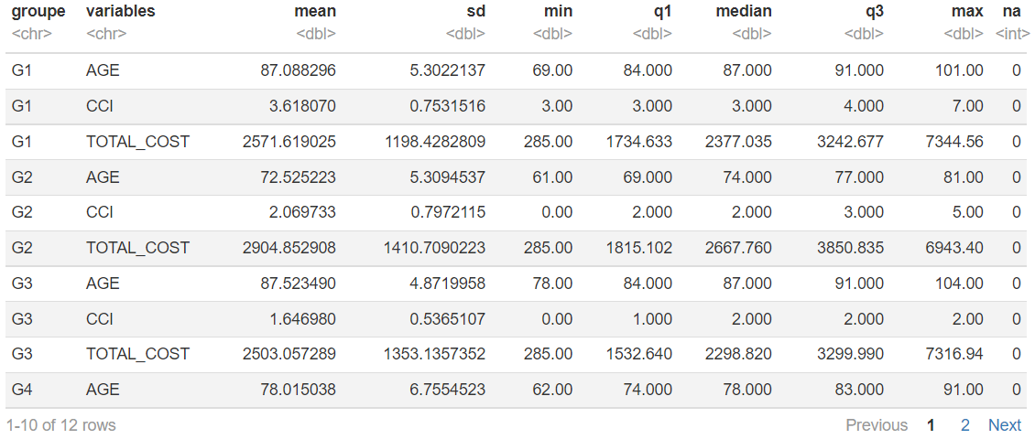
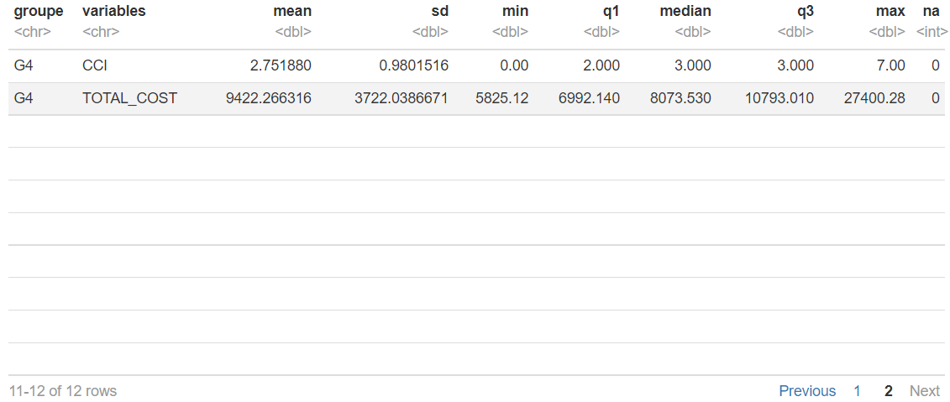

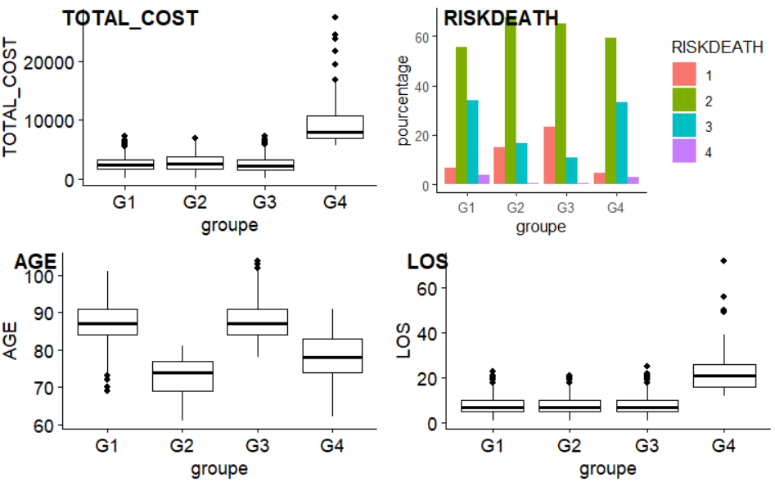
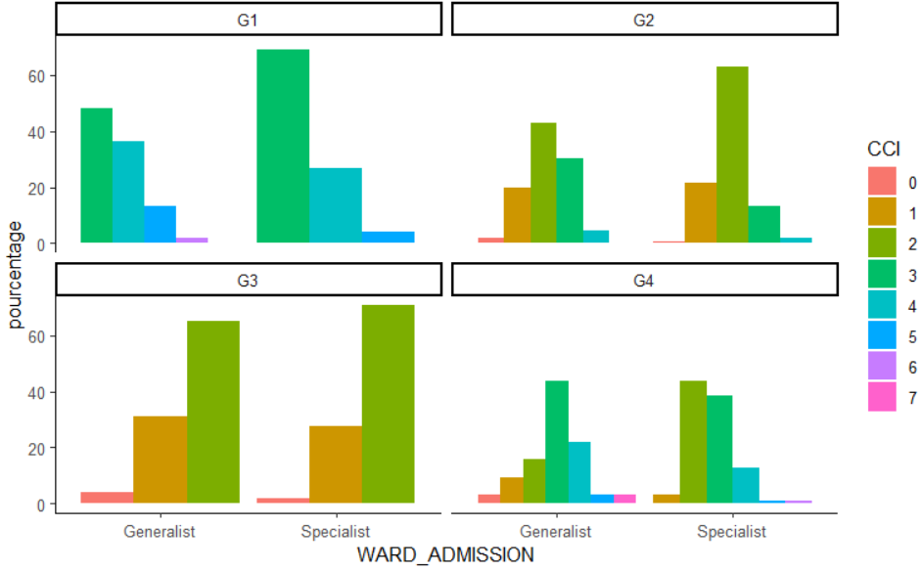

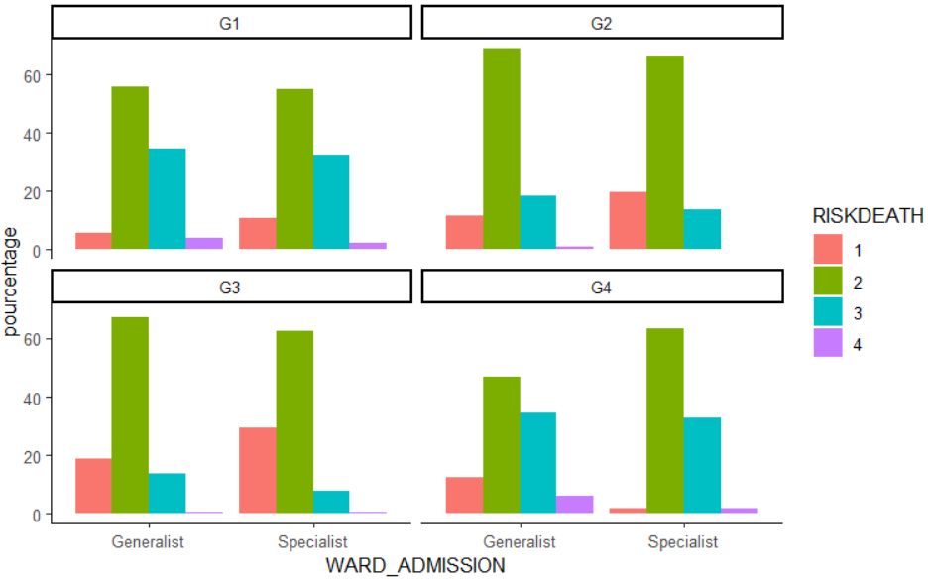
- We can notice that for the case of the TOTAL_COST :
- The highest values are only found within G4, in a group where the variability is particularly high and where the data distribution is clearly asymmetrical;
- The BoxPlots that corresponds to the groups G1, G2 and G3 are more or less on the same level of TOTAL_COST, with in particular a less significant variability compared to that of G4, and the data distribution within those groups are relatively symmetrical;
- Outliers are more significant and higher in terms of TOTAL_COST values for G4, while they are less high and less dispersed in a similar way for G1 and G2. However, they are less numerous and less high in terms of TOTAL_COST values.
- We can notice that for the case of the RISK_DEATH :
- The peak of proportions in each group strongly corresponds (more than 50 % each), to the admissions with a RISK_DEATH level of 2. In a descending order, the peak is higher in G2, then in G3, then in G4 and slightly less high than in all the other groups in G1;
- The proportions of admission with a RISK_DEATH level 3 are relatively similar in G1 and G4, while they are similarly less high in G2 and G3;
- Admissions with a RISK_DEATH level 1 are more frequent in G3, then in G2, whereas they are relatively less frequent in G1 and G4;
- In all the groups, admissions with a RISK_DEATH level 4 are less frequent, even relatively rare for the particular case of the groups G2 and G3;
- We can notice for the case of the AGE :
- Admissions that correspond to the oldest patients are observed within G1 and G3, whereas those which correspond to the less old ones are mainly more concentrated in G2 than in G4;
- Variability is more significant in G2 than in G4, with a noticeable distribution asymmetry in G2. However, this variability is clearly and similarly less significant in G1 and G3, but with more symmetrical distributions;
- Some lower outliers (younger patients) are found in G1 and others in G3 (older patients)
- We can notice for the case of the LOS:
- Admissions with the highest LOS values are concentrated in G4, with the most significant variability of them all and a symmetrical data distribution;
- Admissions concentrated in G1, G2 and G3 are characterized by LOS values that are clearly and above all similarly (between these 3 groups) less significant than in G4, with much lower variability and relatively asymmetrical data distributions;
- Outliers show similarity in G1, G2 and G3, while they are certainly less numerous in G4, bon on the other hand more dispersed.
- For the case of the CCI per WARD_ADMISSION:
- The Index 3 of CCI corresponds to the peak of admissions proportions in G1 (clearly more frequent within the Specialist Wards) and in G4: Generalist Wards;
- The index 2 of CCI corresponds to the peak of admissions proportions in G2 (clearly more frequent in the Specialist Wards), in G3 and in G4: Specialist Wards;
- The index 1 of CCI is frequently more observed (in a particularly similar way) within the admissions, in both Generalist and Specialist Wards, in G2 and in G3. It is less observed in G4 and even literally quasi-unobserved in G1;
- The index 4 of CCI is the more observed within the admissions in G1 (more within the Generalist Wards),a little less in G4 (once again, mainly in Generalist Wards), and more or less rare (even inexistent) in the other Wards of the other groups;
- The index 5 of CCI is not very frequent within the admissions in G1: Generalist Wards and very infrequent within those of G1: Specialist Wards. It is also not very frequent in G4(in both Specialist and Generalist Wards) and relatively inexistent in the other Wards of the groups that have not been mentioned yet;
- The indexes 6 and 7 of CCI are observed only very rarely within the admissions: rarely seen in G1: Generalist Wards and G4: Specialist Wards for the case of index 6 and very little noticed for that of index 7 in G4: Generalist Wards.
- For the case of the RISK_DEATH per WARD_ADMISSION:
- In all of the Wards (both Generalist and Specialist ones), the peaks of proportions clearly correspond to the admissions with a level of RISK_DEATH 2. Let us juts notice that the 2 peaks in G2 and G3 are relatively more significant than those in G1 and G4;
- Let us notice that admissions with a level of RISK_DEATH 3 are similarly quite frequent both in Generalist and Specialist Wards for the groups G1 and G4, less frequent in G2 (both Specialist & Generalist) and relatively not frequent in G3 (once again, in both Generalist and Specialist Wards) ;
- Admissions with a level of RISK-DEATH 1 are quite frequent in the Specialist & Generalist Wards of the group G3, slightly less frequent for the case of G2. This type of admissions is not frequent in G1: Specialist Wards, and very infrequent in G1: Generalist Wards. The situation is reversed for the case of G4;
- Admissions with a level of RISK_DEATH 4 are generally not frequent or even rare in all of the Wards of any group, let’s just insist on the fact that this lower frequency is less significant in G4: Specialist Wards and G3: Generalist Wards, similarly rare in G1: Specialist Wards and G4: Specialist Wards, and very rare within the other Wards not yet discussed.

Model 3 : Examinations costs/specific analysis

df_model3 <- df %>%
select(COST_RADIOLOGY,
COST_LAB,
COST_HAEMATIC,
COST_CONSULTATIONS,
COST_CARDIO,
COST_VAR,
COST_DIAGNOSTIC
) %>%
scale()

fviz_nbclust(df_model3, kmeans, method = "silhouette")
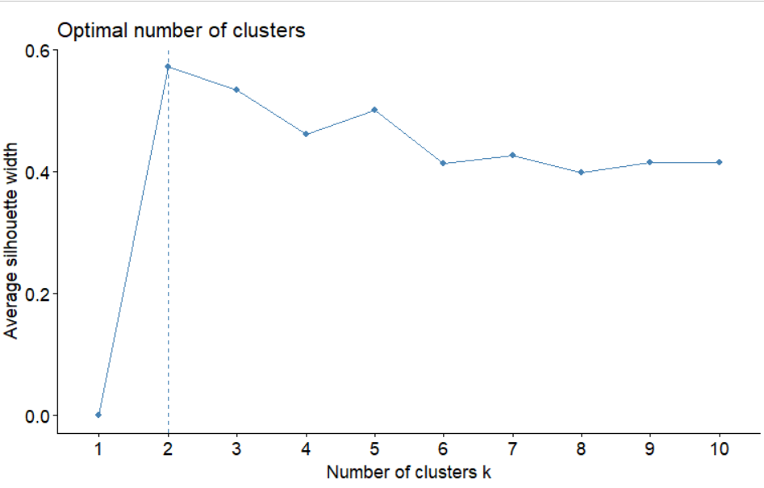

- The data partitioning method that has been chosen was that of the k-means (k-means clustering).
- The method used for estimating the optimal number of Clusters to specify when partitioning data with the k-means method is that of the Average Silhouette Width.
- Based on the curve above, it is clear that we have a maximum value of the Average Silhouette width with 2 clusters, which means that 2 is then the optimal number of Clusters to be kept.

mod3_nc <- 2

mod3 <- kmeans(df_model3,
centers = mod3_nc,
nstart = 10,
iter.max = 200,
)

mod3

K-means clustering with 2 clusters of sizes 2109, 417

Cluster means:
COST_RADIOLOGY COST_LAB COST_HAEMATIC COST_CONSULTATIONS COST_CARDIO COST_VAR COST_DIAGNOSTIC
1 -0.3516754 -0.1240645 -0.04644016 -0.03621574 -0.3516754 -0.2636288 -0.2992636
2 1.7786175 0.6274629 0.23487361 0.18316308 1.7786175 1.3333169 1.5135417

Clustering vector:
[1] 1 1 1 1 1 1 1 1 1 1 1 1 1 1 1 1 1 1 1 1 1 1 1 1 1 1 1 2 2 2 1 1 1 1 1 1 1 1 1 1 1 2 1 1 1 1 1
[48] 1 1 1 2 1 1 1 2 1 1 1 1 1 1 1 1 1 1 1 1 1 1 1 1 1 1 1 1 1 1 1 1 1 1 1 1 1 1 1 1 1 1 1 1 1 1 1
[95] 1 1 1 1 1 1 1 1 1 1 1 1 1 1 1 1 1 1 1 1 1 1 1 1 1 1 1 1 1 1 1 1 1 1 1 1 1 1 1 1 1 1 1 1 1 1 1
[142] 1 1 1 1 1 1 1 1 1 1 1 1 1 1 1 1 1 1 1 1 1 1 1 1 1 1 1 1 1 1 1 1 1 1 1 1 1 1 1 1 1 1 1 1 1 1 1
[189] 1 1 1 1 1 1 1 1 1 1 1 2 2 2 1 1 1 1 1 1 1 1 1 1 1 1 1 1 1 1 1 1 1 1 1 1 1 1 1 1 1 1 1 1 1 1 1
[236] 1 1 1 1 2 1 1 1 1 1 1 1 1 1 1 1 1 1 1 1 1 1 1 1 1 1 1 1 1 1 1 1 1 1 1 1 1 1 1 1 1 1 2 2 2 2 1
[283] 2 1 2 2 1 2 1 1 1 1 1 1 1 2 2 1 1 2 2 2 2 2 2 2 2 2 2 2 2 2 2 2 2 2 2 2 2 2 2 2 2 2 2 2 2 2 2
[330] 2 2 2 2 2 2 2 2 2 2 2 2 2 2 2 2 2 2 2 2 2 2 2 2 2 2 2 2 2 2 2 2 2 2 2 2 2 2 2 2 2 2 2 2 2 2 2
[377] 2 2 2 2 2 2 2 2 2 2 2 2 2 2 2 2 2 2 2 2 2 2 2 2 2 2 2 2 2 2 2 2 2 2 2 2 2 2 2 2 2 2 2 2 2 2 2
[424] 2 2 2 2 2 2 2 2 2 2 2 2 2 2 2 2 2 2 2 2 2 2 2 2 2 2 2 2 2 2 2 2 2 2 2 2 2 2 2 2 2 2 2 2 2 2 2
[471] 2 2 2 2 2 2 2 2 2 2 2 2 2 2 2 2 2 2 2 2 2 2 2 2 2 2 2 2 2 2 2 2 2 2 2 2 2 2 2 2 2 2 2 2 2 2 2
[518] 2 2 2 2 2 2 2 2 2 2 2 2 2 2 2 2 2 2 2 2 2 2 2 2 2 2 2 2 2 2 2 2 2 2 2 2 2 2 2 2 2 2 2 2 2 2 2
[565] 2 2 2 2 2 2 2 2 2 2 2 2 2 2 2 2 2 2 2 2 2 2 2 2 2 2 2 2 2 2 2 2 2 2 2 2 2 2 2 2 2 2 2 2 2 2 2
[612] 2 2 2 2 2 2 2 2 2 2 2 2 2 2 2 2 2 2 2 2 2 2 2 2 2 2 2 2 1 1 1 1 1 1 1 1 1 1 1 1 1 1 1 1 1 1 1
[659] 1 1 1 1 1 1 1 1 1 1 1 1 1 1 1 1 1 1 1 1 1 1 1 1 1 1 1 1 1 1 1 1 2 1 1 1 1 1 1 1 1 1 1 1 1 1 1
[706] 1 1 1 1 1 1 1 1 1 1 1 1 1 1 1 1 1 1 1 1 1 1 1 1 1 1 1 1 1 1 1 1 1 1 1 1 1 1 1 1 1 1 1 1 1 1 1
[753] 1 1 1 1 1 1 1 1 1 1 1 1 1 1 1 1 1 1 1 1 1 1 1 1 1 1 1 1 1 1 1 1 1 1 1 1 1 1 1 1 1 1 1 1 1 1 1
[800] 1 1 1 1 1 1 1 1 1 1 1 1 1 1 1 1 1 1 1 1 1 1 1 1 1 1 1 1 1 1 1 1 1 1 1 1 1 1 1 1 1 1 1 1 1 1 1
[847] 1 1 1 1 1 1 1 1 1 1 1 1 1 1 1 1 1 1 1 1 1 1 1 1 1 1 1 1 1 1 1 1 1 1 1 1 1 1 1 1 1 1 1 1 1 1 1
[894] 1 1 1 1 1 1 1 1 1 1 1 1 1 1 1 1 1 1 1 1 1 1 1 1 1 1 1 1 1 1 1 1 1 1 1 1 1 1 1 1 1 1 1 1 1 1 1
[941] 1 1 1 1 1 1 1 1 1 1 1 1 1 1 1 1 1 1 1 1 1 1 1 1 1 1 1 1 1 1 1 1 1 1 2 2 2 1 1 1 1 1 1 1 1 1 1
[988] 1 1 1 1 2 1 1 1 1 1 1 1 1
[ reached getOption("max.print") -- omitted 1526 entries ]

Within cluster sum of squares by cluster:
[1] 4673.694 7568.315
(between_SS / total_SS = 30.7 %)

Available components:

[1] "cluster" "centers" "totss" "withinss" "tot.withinss" "betweenss"
[7] "size" "iter" "ifault"

- The number of observations for each of the 2 clusters will be respectively: 2109 and 417 observations;
- The coordinates (COST_RADIOLOGY, COST_LAB COST_HAEMATIC, COST_CONSULTATIONS, COST_CARDIO, COST_VAR COST_DIAGNOSTIC) of each Centroid (Position of the Cluster’s center) of each Cluster will be as follows:
- Centroid of Cluster 1 : (-0.3516754, -0.1240645, -0.04644016, -0.03621574, -0.3516754, -0.2636288, -0.2992636) ;
- Centroid of Cluster 2 : (1.7786175, 0.6274629, 0.23487361, 0.18316308, 1.7786175, 1.3333169, 1.5135417) ;
- Based on the Clustering Vector above, we can consult the Cluster of membership of each line of observations on admissions by just looking at the number of Cluster representing the line of observations on the latter’s position within the vector: line 1 belongs to Cluster 1, line 2 belongs to Cluster 1, line 988 belongs to Cluster 1… ;
- The sum of the squares of the distances between the points of a Cluster and their Centroid for each of the Cluster 1 and 2 are respectively 4 673.694 and 7 568.315. From these values, we can deduce that the Cluster 1 is the most compact of the two, whereas the Cluster 2 is the less compact one;
- However, let’s notice that the ratio “ between_SS / total_SS = 30.7 % ” is not necessarily (perhaps far from being) a good sign that we have a good enough Clustering here.
Residuals:
res.mod3 <- df %>%
mutate(groupe= paste0('G',mod3$cluster))

- We have named our Cluster 1 and 2 respectively by « G1 » and « G2 ».
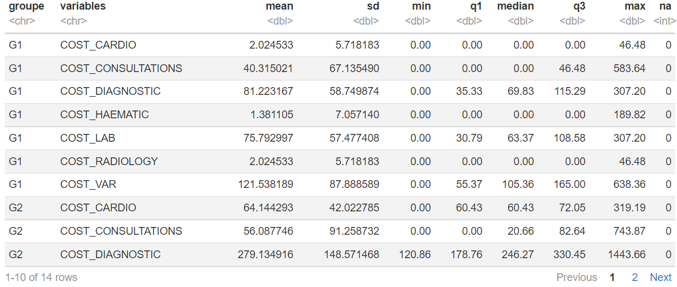
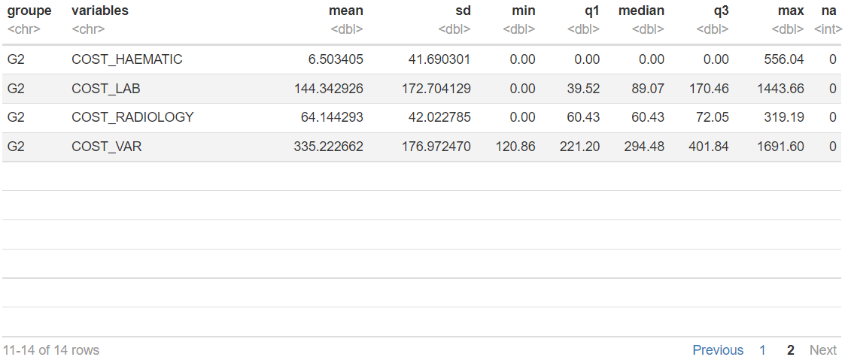
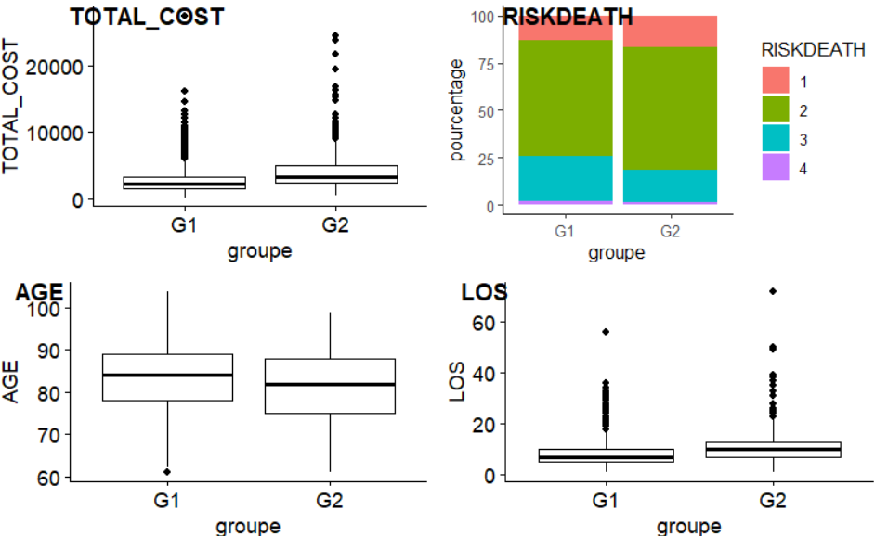

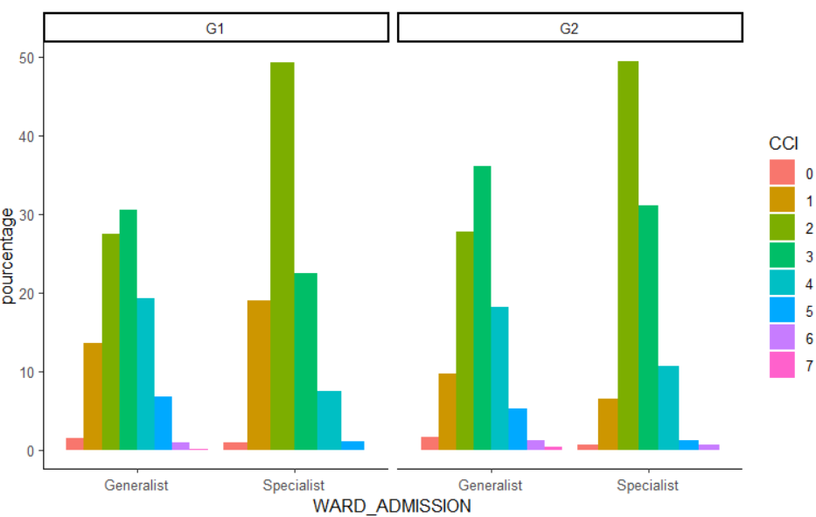
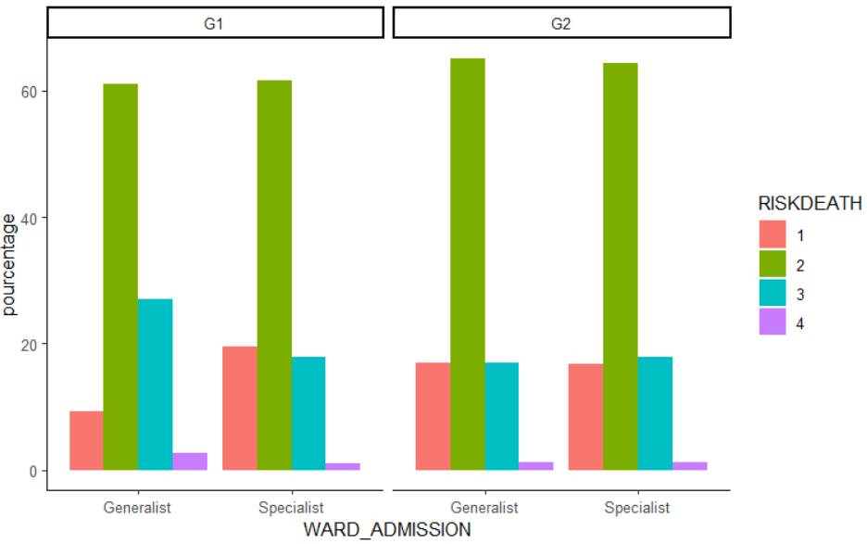
- We can notice for the case of the TOTAL_COST :
- The highest TOTAL_COST are found among the admissions in G2, and the lowest in G1;
- The variability is more significant in G2 than in G1 and the data distribution is more asymmetrical in G2 than in G1;
- Outliers with regard to the TOTAL_COST values are more significant and more dispersed in G2 than in G1.
- We can notice for the case of the RISK_DEATH :
- Admissions with a level of RISK_DEATH 2 are relatively similar in terms of proportions in the Groups G1 and G2;
- Admissions with a level of RISK_DEATH 3 are slightly more frequent in G1 than in G2, whereas the situation is reversed when it comes to admissions with a level of RISK_DEATH 1;
- Admissions with a level of RISK_DEATH 4 are relatively rare within the two groups.
- We can notice for the case of the AGE :
- Age values are slightly higher in G1 than in G2 (the lowest age values of admitted patients are found within the latter), with however a more significant variability for the case of G2;
- Data distribution is slightly more symmetrical in G2 than in G1;
- No indication of the existence of eventual outliers is reported when we look at the two BoxPlots.
- For the case of the LOS :
- Les valeurs de LOS sont légèrement plus élevées en G2 qu’en G1, tandis que la variabilité (peu importante) et la symétrie (relativement symétrique) de la distribution des données sont relativement similaires en ce qui concerne les deux groupes ;
- LOS values are slightly higher in G2 than in G1, whereas the variability (poorly significant) and the symmetry (relatively symmetrical) of the data distribution are relatively similar regarding the two groups;
- Outliers are more scattered in G2 (with the highest values) than in G1;
- En ce qui concerne les CCI par WARD_ADMISSION :
- Dans les deux groupes, le pic des admissions en Wards Specialist (pics similaires) correspond à celle avec des indices 2 de CCI, tandis que ce sont les admissions avec les indices 3 qui constituent les pics en Wards Generalist (pic plus important en G2 : Wards Generalist) ;
- Les admissions avec un indice de CCI 4 sont relativement similaires en terme de proportion en G1 : Wards Generalist et en G2 : Wards Generalist, tandis que dans les Wards Specialist, ce type d’admission est plus fréquent en G2 qu’en G1 ;
- Les admissions avec un indice de CCI 5 sont peu fréquentes dans les deux groupes pour le cas des Wards Generalist (juste légèrement plus fréquentes en Groupe G1), tandis que dans les Wards Specialist, ce type d’admission est similairement très peu fréquent dans les deux groupes ;
- Les admissions avec des indices de CCI 6 et 7 sont très peu fréquentes ou rares (voir même totalement absentes pour le cas des Wards Specialist en G1) dans tous les Wards des deux groupes.
- En ce qui concerne les RISK_DEATH par WARD_ADMISSION :
- Que ce soit en G1 ou en G2, les pics dans tous les Wards correspondent aux admissions avec un RISK_DEATH 2 (généralement légèrement plus importants dans G2) ;
- Les admissions avec un niveau RISK_DEATH de niveau 3 sont plus importantes en termes de proportions en G1 : Wards Generalist qu’en G2 : Wards Generalist, tandis que ce type d’admissions est assez similairement fréquent dans les Wards Specialist des deux groupes ;
- Les admissions avec un niveau RISK_DEATH 1 sont légèrement plus fréquentes en G1 : Wards Specialist qu’en G2 : Wards Specialist, tandis que ce type d’admission est clairement moins fréquent en G1 : Wards Generalist qu’en G2 : Wards Generalist ;
- Les admissions avec un niveau de RISK_DEATH 4 sont peu fréquentes dans tous les Wards des deux groupes, avec peut-être juste une attention particulière portée au cas de la proportion constatée en G1 : Wards Generalist qui semble y être légèrement plus importante que dans les autres Wards.

Modèle 4 : Département d’admission, risque de décès et durée de séjour

df_model4 <- df %>%
select( IDADMISSION,WARD_ADMISSION, RISKDEATH) %>%
mutate(RISKDEATH= paste0("Risk_Death_", RISKDEATH),
WARD_ADMISSION= paste0("WS", WARD_ADMISSION)
) %>%
mutate(val = 1) %>%
spread(RISKDEATH, val, fill = 0 ) %>%
mutate(val = 1) %>%
spread(WARD_ADMISSION, val, fill = 0 ) %>%
select(- IDADMISSION)

fviz_nbclust(df_model4, kmeans, method = "silhouette")
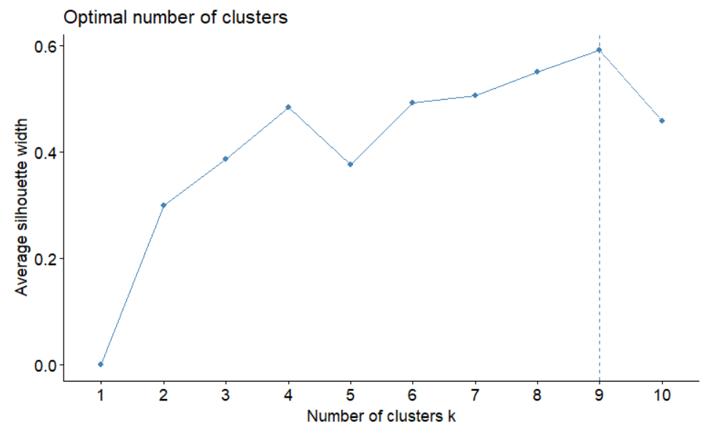
- La méthode de partitionnement de données choisie est le partitionnement en k-moyennes (k-means clustering).
- La méthode utilisée pour la l’estimation du nombre optimal de Clusters à spécifier lors du partitionnement des données avec la méthode de k-means est celle de l’Average Silhouette.
- En se basant sur le graphique ci-dessus, il est clair que nous avons une valeur maximum de l’Average Silouhette width avec 9 clusters, signifiant que 9 est alors le nombre optimal de Clusters retenu.
mod4_nc <- 9

mod4 <- kmeans(df_model4,
centers = mod4_nc,
nstart = 10,
iter.max = 200,
)

mod4

K-means clustering with 9 clusters of sizes 490, 515, 283, 266, 634, 110, 107, 92, 29

Cluster means:
Risk_Death_1 Risk_Death_2 Risk_Death_3 Risk_Death_4 WS08 WS21 WS24 WS2604
1 0.1877551 0.6897959 0.1102041 0.01224490 0.000000000 0.0000000 0.00000000 1
2 0.0000000 0.0000000 1.0000000 0.00000000 0.009708738 0.1825243 0.06601942 0
3 0.2190813 0.7526502 0.0000000 0.02826855 0.000000000 1.0000000 0.00000000 0
4 0.0000000 1.0000000 0.0000000 0.00000000 0.000000000 0.0000000 0.14285714 0
5 0.0000000 1.0000000 0.0000000 0.00000000 0.000000000 0.0000000 0.00000000 0
6 0.0000000 1.0000000 0.0000000 0.00000000 1.000000000 0.0000000 0.00000000 0
7 0.6915888 0.0000000 0.0000000 0.30841121 0.000000000 0.0000000 0.00000000 0
8 1.0000000 0.0000000 0.0000000 0.00000000 1.000000000 0.0000000 0.00000000 0
9 0.9310345 0.0000000 0.0000000 0.06896552 0.000000000 0.0000000 0.58620690 0
WS2605 WS68
1 0.0000000 0.00000000
2 0.6718447 0.06990291
3 0.0000000 0.00000000
4 0.0000000 0.85714286
5 1.0000000 0.00000000
6 0.0000000 0.00000000
7 1.0000000 0.00000000
8 0.0000000 0.00000000
9 0.0000000 0.41379310

Clustering vector:
[1] 1 2 5 1 1 1 2 1 2 2 2 1 8 6 1 1 1 2 2 2 5 1 5 5 5 2 4 5 1 6 1 5 7 1 3 1 8 4 6 5 1 1 6 2 4 4 1
[48] 7 5 5 5 4 5 5 7 5 3 5 5 5 3 9 2 3 7 3 5 3 9 6 4 3 7 5 1 4 2 1 1 2 2 2 6 6 1 3 8 5 2 7 5 5 1 2
[95] 5 3 1 5 1 5 7 4 4 1 7 8 4 5 1 5 7 5 5 1 3 5 4 1 3 3 7 5 1 5 5 5 1 4 5 5 5 2 7 8 4 6 5 5 5 1 1
[142] 4 5 4 4 4 5 1 6 1 5 5 3 5 1 4 5 3 5 4 1 5 5 5 1 6 4 1 5 5 1 2 3 1 7 2 2 5 1 1 5 2 5 2 1 2 3 2
[189] 1 2 1 5 1 2 2 4 4 8 5 2 2 3 5 2 5 3 1 7 1 3 8 2 5 1 2 6 5 1 1 1 6 2 1 5 6 5 3 5 2 5 5 3 5 6 2
[236] 1 3 5 5 5 2 5 8 3 2 7 3 4 5 1 3 5 1 1 5 3 3 1 3 4 5 5 4 2 2 2 2 5 2 3 5 8 7 1 3 2 3 4 1 3 2 5
[283] 5 2 1 2 5 5 2 2 4 1 2 1 6 4 8 5 4 5 2 4 8 2 2 1 1 5 4 1 7 6 1 2 5 1 3 2 1 1 5 2 7 5 3 8 3 2 5
[330] 4 4 1 5 5 2 3 5 1 2 1 5 2 7 2 2 5 2 2 5 5 2 1 4 1 2 5 5 1 3 5 5 7 5 5 5 2 1 2 3 1 5 4 5 1 3 5
[377] 1 8 5 5 2 2 4 1 4 5 2 6 4 6 5 4 3 4 5 3 8 5 1 1 4 2 1 1 7 5 2 1 4 9 3 5 2 2 2 5 1 1 2 1 5 4 3
[424] 5 1 3 4 7 5 4 5 3 5 2 1 1 4 3 9 4 1 1 8 1 2 5 5 5 2 4 5 9 5 3 4 6 7 4 4 2 5 3 3 2 2 4 5 2 4 2
[471] 2 1 2 5 2 2 1 8 7 5 2 5 1 1 5 2 6 7 1 2 2 5 1 5 5 5 7 5 5 7 5 2 5 3 2 2 1 5 4 5 2 1 5 4 5 3 5
[518] 3 1 2 4 4 1 4 2 2 1 5 1 6 2 6 5 5 4 1 1 1 2 5 2 1 5 4 1 4 5 4 1 2 5 2 5 2 1 5 4 3 5 4 3 2 5 1
[565] 2 5 5 5 5 5 6 1 7 5 5 5 5 6 7 6 2 1 2 5 5 5 3 3 6 4 3 2 2 7 2 1 5 7 1 2 2 3 1 1 3 5 1 5 1 2 5
[612] 6 5 8 2 5 8 7 5 5 2 4 1 6 2 1 1 2 7 4 6 1 2 5 4 5 2 1 3 2 3 1 3 2 1 8 5 2 2 1 4 1 5 5 2 1 2 2
[659] 5 8 5 5 4 1 5 5 2 6 7 4 3 1 2 2 6 3 6 5 1 5 6 2 7 1 4 8 4 2 4 3 4 5 5 5 1 7 8 2 4 8 3 6 5 5 3
[706] 3 3 1 6 6 1 5 5 1 5 5 6 4 1 5 3 3 2 3 2 2 5 1 2 2 5 1 4 2 6 1 4 1 4 5 2 2 2 2 5 1 1 5 1 5 5 4
[753] 5 5 3 3 4 5 2 9 1 5 4 3 1 2 8 4 1 8 3 2 5 1 1 5 5 5 5 4 1 1 1 5 2 2 4 5 3 1 3 5 1 1 7 4 3 1 8
[800] 1 2 1 2 5 1 1 5 1 2 4 5 5 2 2 6 1 3 2 3 3 1 2 7 4 2 5 3 5 2 1 1 8 3 8 2 3 1 1 3 5 2 6 2 5 3 5
[847] 5 3 5 4 2 5 4 4 1 2 5 3 5 3 4 2 2 1 1 8 5 2 2 5 1 1 2 1 5 5 5 9 6 3 1 1 4 2 5 4 5 2 4 2 4 1 2
[894] 5 4 5 2 5 4 5 1 1 1 4 5 1 1 5 5 2 1 3 2 5 2 8 4 4 5 7 3 5 3 2 1 2 5 5 5 8 1 2 2 5 2 6 5 2 6 5
[941] 4 8 4 5 2 5 5 3 8 4 4 2 5 4 1 9 3 3 5 1 7 1 2 1 2 2 3 1 9 2 3 3 5 1 2 1 1 2 2 2 5 9 1 1 2 7 8
[988] 5 9 2 1 6 4 7 2 1 5 2 4 1
[ reached getOption("max.print") -- omitted 1526 entries ]

Within cluster sum of squares by cluster:
[1] 233.55102 260.57476 108.87633 65.14286 0.00000 0.00000 45.64486 0.00000 17.79310
(between_SS / total_SS = 77.4 %)

Available components:

[1] "cluster" "centers" "totss" "withinss" "tot.withinss" "betweenss"
[7] "size"

- Le nombre d’observations pour chacun des 9 clusters sera respectivement de : 490, 515, 283, 266, 634, 110, 107, 92 et de 29 observations.
- Les coordonnées (Risk_Death_1, Risk_Death_2, Risk_Death_3, Risk_Death_4, WS08, WS21, WS24, WS2604, WS2605, WS68) de chaque Centroid (position du centre de Cluster) de chaque Cluster sont les suivantes:
- Centroid de Cluster 1 : (0.1877551, 0.6897959, 0.1102041, 0.01224490, 0.000000000, 0.0000000, 0.00000000, 1, 0.0000000, 0.00000000) ;
- Centroid de Cluster 2 : (0.0000000, 0.0000000, 1.0000000, 0.00000000, 0.009708738, 0.1825243, 0.06601942, 0, 0.6718447, 0.06990291) ;
- Centroid de Cluster 3 : (0.2190813, 0.7526502, 0.0000000, 0.02826855, 0.000000000, 1.0000000, 0.00000000, 0, 0.0000000, 0.00000000) ;
- Centroid de Cluster 4 : (0.0000000, 1.0000000, 0.0000000, 0.00000000, 0.000000000, 0.0000000, 0.14285714 0, 0.0000000, 0.85714286).
- Centroid de Cluster 5 : (0.0000000, 1.0000000, 0.0000000, 0.00000000, 0.000000000, 0.0000000, 0.00000000, 0, 1.0000000, 0.00000000).
- Centroid de Cluster 6 : (0.0000000, 1.0000000, 0.0000000, 0.00000000, 1.000000000, 0.0000000, 0.00000000, 0, 0.0000000, 0.00000000).
- Centroid de Cluster 7 : (0.6915888, 0.0000000, 0.0000000, 0.30841121, 0.000000000, 0.0000000, 0.00000000, 0, 1.0000000, 0.00000000).
- Centroid de Cluster 8 : (1.0000000, 0.0000000, 0.0000000, 0.00000000, 1.000000000, 0.0000000, 0.00000000, 0, 0.0000000, 0.00000000).
- Centroid de Cluster 9 : (0.9310345, 0.0000000, 0.0000000, 0.06896552, 0.000000000, 0.0000000, 0.58620690, 0, 0.0000000, 0.41379310).
- A partir du Clustering Vector ci-dessus, nous pouvons consulter le Cluster d’appartenance de chaque ligne d’observations sur les admissions en consultant juste le numéro de cluster qui représente la ligne d’observations sur la position de cette dernière dans le vecteur : ligne 1 appartient à Cluster 1, ligne 2 appartient à Cluster 2, ligne 988 appartient à Cluster 5…
- La Somme des carrées des distances des points d’un Cluster à leur Centroid pour chacun des Clusters 1, 2, 3, 4, 5, 6, 7, 8 et 9 sont respectivement de : 233.55102, 260.57476, 108.87633, 65.14286, 0.00000, 0.00000, 45.64486, 0.00000 et de 17.79310. A partir de ces valeurs, nous pouvons en classer dans l’ordre décroissant des Clusters, du moins compact au plus compact : Cluster 5 – Cluster 6 – Cluster 8 – Cluster 9 – Cluster 7 – Cluster 4 – Cluster 3 – Cluster 1 – Cluster 2 .
- Le ratio “between_SS / total_SS = 77.4 %” peut nous indiquer que nous avons là un Clustering relativement bon.

Résidus :
mod4Ordre <- paste0('G',1:mod4_nc)

- Nous avons nommé nos Clusters respectivement par « G1 », « G2 », « G3 », « G4 », « G5 », « G6 », « G7 », « G8 » et « G9 ».

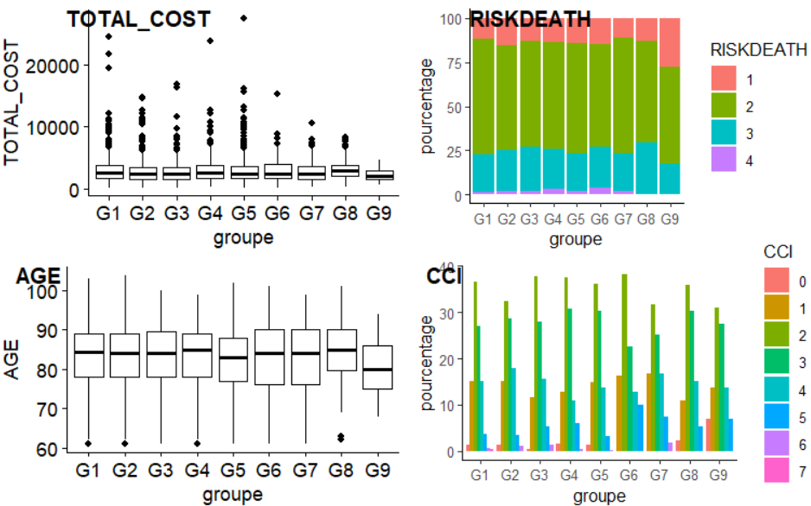

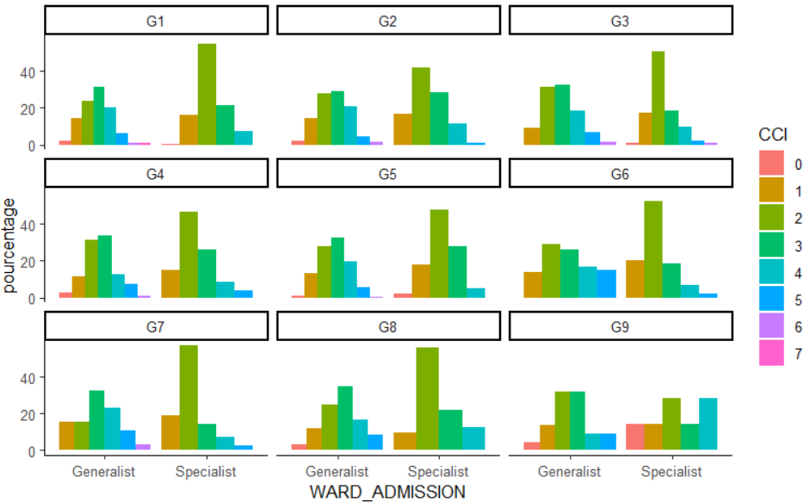

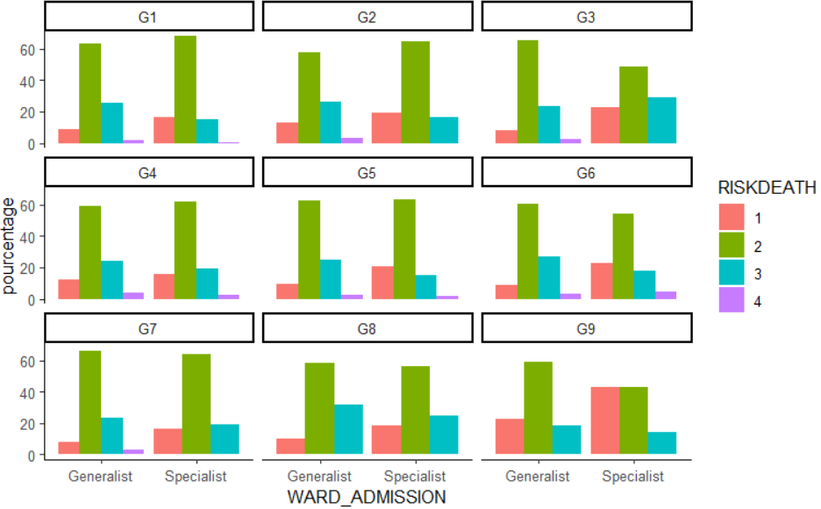
- Nous pouvons remarquer que pour le cas des TOTAL_COST:
- Les BoxPlots correspondant aux Groupes se trouvent à peu près aux mêmes niveaux de valeurs de TOTAL_COST, avec quelques exceptions près pour les cas du G1, G6 et G8 ayant les valeurs les plus élevées et pour ceux de G7 et G9 avec les valeurs les moins élevées ;
- Les variabilités sont plus importantes pour G6 et G7, tandis qu’elles le sont peu avec G9 ;
- En ce qui concerne la symétrie de la distribution des données, tous les BoxPlots des Groupes semblent montrer une relative symétrie, à l’exception de celui du G7, présentant une asymétrie assez importante.
- Les données aberrantes sont plus importantes au sein de G1, G2 et de G5 (correspondant notamment à la valeur aberrante la plus élevée constaté), tandis qu’elles le sont nettement moins au sein de G6, G7 et de G8, voir même inexistantes au sein de G9.
- Nous pouvons remarquer que pour le cas des RISK_DEATH:
- Pour tous les groupes, les admissions avec le niveau de RISK_DEATH 2 constituent le pic des proportions.
- Les admissions avec un niveau de RISK_DEATH 1 sont particulièrement fréquentes en G9, tandis que ce type d’admissions est moins fréquent au sein de G1 et G7 ;
- Les admissions avec un niveau de RISK_DEATH 3 sont particulièrement fréquentes au sein de G8, tandis que les autres groupes présentent chacune une proportion relativement similaire lorsqu’il s’agit des admissions liées à ce risque.
- Les admissions avec un RISK_DEATH de niveau 4 sont généralement peu fréquentes (G4 et G6), rares (G1, G2, G3, G5, G7) ou même inexistantes (G8 et G9) dans tous les groupes.
- Pour ce qui est du cas des AGE:
- Pour les cas des valeurs d’âges les plus élevées, nous pouvons constater à partir des BoxPlots correspondants que les Groupes G1, G2, G3, G4, G6, G7 et G8 sont relativement concernés par ces valeurs, tandis que pour le cas des valeurs moins élevées, ce sont les groupes G6 (avec une grande variabilité, distribution de données légèrement asymétrique), G7 (avec une grande variabilité, distribution de données légèrement asymétrique) et G9 qui sont les plus concernés.
- A part les groupes G6 et G7 déjà mentionnés précédemment, les variabilités et les distributions de données dans les autres groupes semblent toutes être à peu près similaires les unes aux autres.
- Quelques données aberrantes peuvent être remarquées au sein de G1, G2, G4 et de G8.
- Pour ce qui est du cas des CCI:
- Dans quasiment tous les groupes, les admissions avec un indice de CCI 2 constituent le pic de proportion (pics légèrement plus importants en G6, G3 et G4, et moins importants en G9, G7 et G2) ;
- Les admissions avec un CCI 3 sont généralement assez fréquentes au sein de groupes (moins importantes tout de même en G6 et G7 comparés aux proportions des autres groupes) ;
- Les admissions avec des CCI 5 et 4 sont quant à elles généralement moins fréquentes dans les groupes (particulièrement au sein de G1 et de G2, mais aussi au sein de G5 pour le cas du CCI 5) ;
- Les admissions avec des CCI 6 et 7 demeurent plus ou moins peu fréquentes dans tous les groupes, voir même inexistantes dans quelque uns (G9, G8, G6).
- Pour ce qui est du cas des CCI par WARD_ADMISSION:
- Pour tous les Wards Specialist de chaque groupe, nous remarquons clairement que les admissions avec un indice CCI 2 constituent les pics des proportions (pic particulièrement moins important en G9 : Wards Specialist) ;
- Pour tous les Wards Generalist de chaque groupe, ce sont les admissions avec un indice de CCI 3 qui forment les pics de proportions (pic exceptionnellement moins important pour le cas de G9) ;
- Excepté en G9 : Wards Specialist (exceptionnellement plus fréquentes), les admissions avec des CCI 4 et 5 sont relativement moins fréquentes au sein des Wards Specialist des groupes ; Tandis que pour le cas des Wards Generalist, à l’exception de G6, ces types d’admissions sont moins fréquents au sein des groupes.
- Les admissions correspondant à des CCI 6 et 7 sont plutôt rares quant à leur part dans la majorité des Wards de chaque groupe, voir même inexistantes dès fois.
- Pour ce qui est du cas des RISK_DEATH par WARD_ADMISSION:
- Que ce soit dans les Wards Generalist ou Specialist, les admissions avec un RISK_DEATH 2 constituent toujours les pics de proportions ;
- A l’exception de G3, les admissions avec un RISK_DEATH 3 sont plus fréquentes en Wards Generalist qu’en Wards Specialist dans tous les groupes ;
- Les admissions avec un RISK_DEATH 1 sont généralement plus fréquentes en Wards Specialist qu’en Ward Generalist, avec une attention particulière portée au groupe G9, là où ce type d’admission est exceptionnellement plus fréquent en Wards Specialist.
- Les admissions avec un RISK_DEATH 4 sont peu fréquentes, rares, voir même inexistantes (G8 et G9) dans les Wards des groupes.

Modèle 5 : Durée de séjour et risque de décès

df_model5 <- df %>%
select(LOS, RISKDEATH) %>%
scale()

fviz_nbclust(df_model5, kmeans, method = "silhouette")

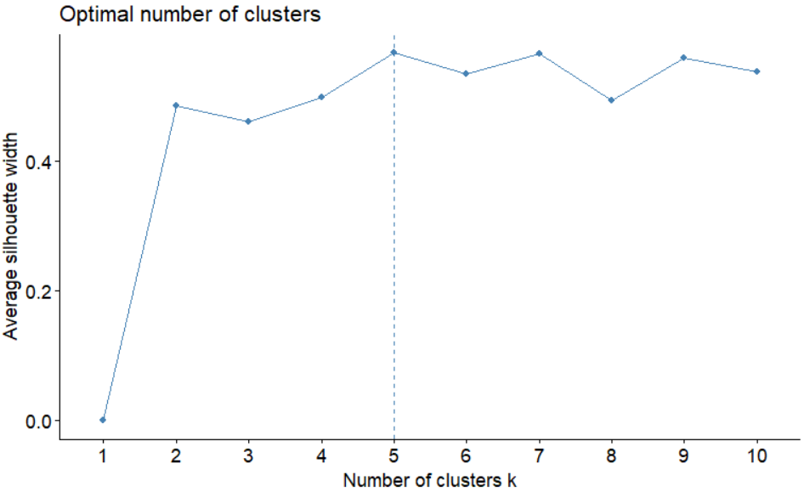
- La méthode de partitionnement de données choisie est le partitionnement en k-moyennes (k-means clustering).
- La méthode utilisée pour l’estimation du nombre optimal de Clusters à spécifier lors du partitionnement des données avec la méthode de k-means est celle de l’Average Silhouette.
- En se basant sur le graphique ci-dessus, il est clair que nous avons une valeur maximum de l’Average Silouhette width avec 5 clusters, signifiant que 5 est alors le nombre optimal de Clusters retenu.
mod5_nc <- 5

mod5 <- kmeans(df_model5,
centers = mod5_nc,
nstart = 10,
iter.max = 200,
)

mod5

K-means clustering with 5 clusters of sizes 568, 337, 913, 553, 155

Cluster means:
LOS RISKDEATH
1 0.5084901 -0.2079862
2 -0.3391334 -1.7295931
3 -0.5555552 -0.1944729
4 -0.1548816 1.4572387
5 2.6989485 0.4690952

Clustering vector:
[1] 1 1 1 3 2 1 2 1 2 3 4 1 1 2 2 5 3 4 2 3 1 1 3 1 3 2 4 3 3 1 1 1 1 1 1 1 1 1 1 2 1 1 3 1 5 5 3
[48] 1 3 3 5 5 4 5 3 2 3 4 4 3 3 2 2 1 2 3 3 3 3 2 1 1 4 3 3 1 3 1 3 3 2 3 3 3 3 1 3 2 3 3 2 3 3 3
[95] 3 2 3 3 3 2 3 2 1 2 3 3 3 3 3 2 2 3 3 3 2 3 2 3 3 4 1 2 3 3 2 3 1 3 3 2 2 3 1 3 1 3 3 2 3 3 1
[142] 3 2 1 4 3 1 3 4 1 1 3 3 3 4 4 3 2 2 2 3 2 5 3 3 2 4 1 2 2 3 3 4 3 3 3 2 1 1 3 2 3 3 3 3 4 1 2
[189] 3 3 2 2 1 1 2 3 3 2 2 3 2 2 3 1 3 2 5 4 2 1 1 5 1 5 2 2 3 1 1 4 5 3 1 1 1 1 2 3 3 2 1 2 3 3 1
[236] 2 1 5 3 1 2 1 1 1 1 3 2 2 2 2 1 2 2 1 3 3 2 2 4 3 2 3 3 2 2 2 3 1 2 1 1 3 2 3 2 1 3 2 3 2 2 1
[283] 1 3 5 4 4 5 2 4 2 2 3 2 3 1 1 2 2 2 3 2 1 2 4 4 1 1 5 1 4 1 3 1 5 3 4 1 1 2 4 1 1 3 1 3 1 3 3
[330] 4 5 1 1 1 3 3 4 5 5 2 1 1 3 4 1 1 1 2 4 3 2 4 5 3 3 3 4 1 3 4 1 3 3 5 5 5 3 2 5 1 1 4 5 5 5 5
[377] 1 5 1 1 1 5 5 4 4 1 3 3 3 3 3 5 4 4 2 5 4 1 5 1 3 1 5 1 1 3 3 3 5 1 3 4 1 3 3 3 2 4 4 1 3 2 4
[424] 5 3 4 4 3 1 4 1 1 2 1 1 3 3 5 2 2 3 3 2 1 3 3 1 1 2 2 2 3 1 3 2 4 1 2 2 5 1 3 1 2 3 1 4 1 1 5
[471] 1 3 2 3 1 4 1 3 2 3 2 2 3 4 2 2 3 3 4 3 3 2 1 3 3 2 2 1 2 2 3 3 1 2 2 3 2 2 3 2 1 3 3 1 4 5 3
[518] 3 1 1 1 1 1 1 3 5 3 2 2 1 5 2 4 5 2 3 1 1 4 3 1 4 1 1 1 5 3 2 3 3 1 1 1 3 1 3 3 2 2 1 3 1 1 1
[565] 5 5 3 3 2 5 5 3 3 2 1 1 2 2 3 3 1 1 1 1 1 1 4 5 1 1 4 1 1 3 1 1 2 4 3 3 4 1 5 5 5 4 5 2 3 3 4
[612] 4 1 5 2 2 5 4 1 2 1 2 3 2 1 1 1 1 5 5 4 5 5 1 1 1 2 5 5 3 1 4 4 5 4 2 4 4 1 3 1 4 5 5 3 1 4 3
[659] 3 4 1 3 3 3 1 1 3 4 4 4 1 1 4 5 4 4 1 3 2 4 1 4 4 1 1 1 5 5 5 5 4 1 1 3 4 2 4 4 4 3 1 1 4 1 3
[706] 4 1 1 3 3 3 4 3 1 1 1 3 4 1 4 2 3 1 3 4 5 3 3 3 3 4 3 3 3 2 4 1 1 1 3 4 4 3 1 4 3 3 3 4 4 3 1
[753] 1 4 1 1 3 4 3 4 5 1 1 3 4 5 2 3 3 3 1 1 4 4 2 4 3 4 3 5 4 4 2 3 4 1 4 2 3 3 3 1 4 1 1 5 3 3 1
[800] 2 3 2 3 3 3 3 4 1 4 1 4 3 3 2 1 3 2 3 2 5 3 1 1 3 3 3 1 4 1 3 3 4 3 4 3 1 1 3 1 4 4 3 3 3 4 1
[847] 4 4 3 4 3 3 1 3 1 1 3 4 1 4 1 1 1 2 4 1 5 1 4 3 1 3 4 4 3 2 2 1 4 4 3 3 4 3 4 1 4 4 3 4 3 4 4
[894] 3 1 1 4 4 4 1 4 4 1 3 3 4 4 1 4 4 3 1 2 3 5 1 4 1 4 3 3 1 4 2 3 2 4 4 3 4 4 1 4 5 5 3 3 4 3 3
[941] 3 1 4 2 3 1 3 4 1 1 1 3 1 4 3 2 3 4 3 3 1 2 3 4 4 3 2 3 2 4 5 1 4 1 2 1 1 1 4 3 1 2 1 2 2 1 4
[988] 4 1 3 3 3 4 1 3 3 2 2 1 3
[ reached getOption("max.print") -- omitted 1526 entries ]

Within cluster sum of squares by cluster:
[1] 126.5125 114.9211 103.1526 369.1019 450.9033
(between_SS / total_SS = 76.9 %)

Available components:

[1] "cluster" "centers" "totss" "withinss" "tot.withinss" "betweenss"
[7] "size" "iter" "ifault"

- Le nombre d’observations pour chacun des 5 clusters sera respectivement de : 568, 337, 913, 553 et de 155 observations.
- Les coordonnées (LOS, RISKDEATH) de chaque Centroid (position du centre de Cluster) de chaque Cluster sont les suivantes:
- Centroid de Cluster 1 : 0.5084901, -0.2079862) ;
- Centroid de Cluster 2 : (-0.3391334, -1.7295931) ;
- Centroid de Cluster 3 : (-0.5555552, -0.1944729) ;
- Centroid de Cluster 4 : (-0.1548816, 1.4572387) ;
- Centroid de Cluster 5 : (2.6989485, 0.4690952) ;
- A partir du Clustering Vector ci-dessus, nous pouvons consulter le Cluster d’appartenance de chaque ligne d’observations sur les admissions en consultant juste le numéro de cluster qui représente la ligne d’observations sur la position de cette dernière dans le vecteur : ligne 1 appartient à Cluster 1, ligne 2 appartient à Cluster 1, ligne 988 appartient à Cluster 4…
- La Somme des carrées des distances des points d’un Cluster à leur Centroid pour chacun des Clusters 1, 2, 3, 4 et 5 sont respectivement de 126.5125, 114.9211, 103.1526, 369.1019 et de 450.9033. A partir de ces valeurs, nous pouvons classer dans l’ordre décroissant les Clusters, du plus compact au moins compact : Cluster 3 – Cluster 2 – Cluster 1 – Cluster 4 – Cluster 5.
- Le ratio “ between_SS / total_SS = 76.9 %” peut nous indiquer que nous avons là un Clustering relativement bon.

Résidus :
res.mod5 <- df %>%
mutate(groupe= paste0('G',mod5$cluster))

- Nous avons nommé nos Clusters respectivement par « G1 », « G2 », « G3 », « G4 » et « G5 ».
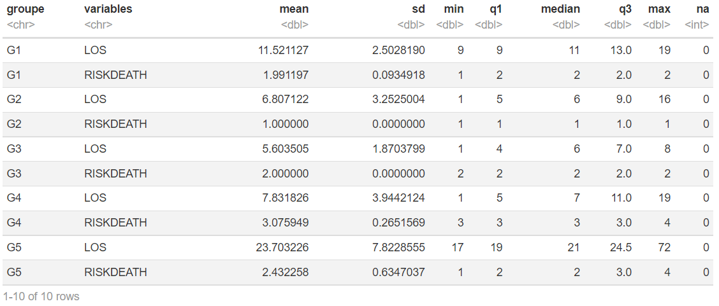

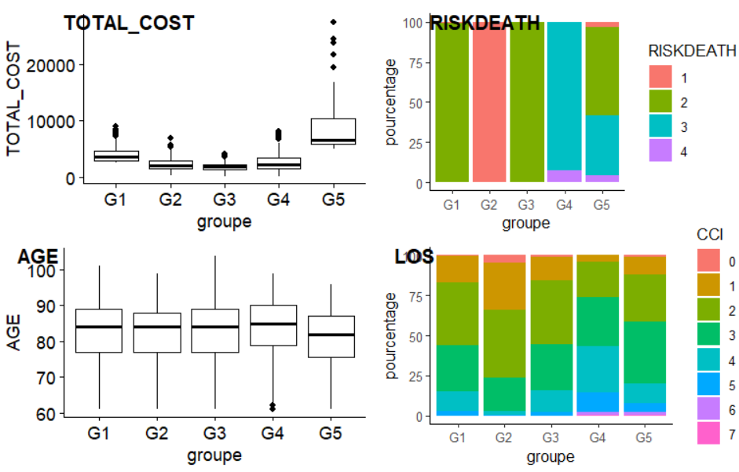
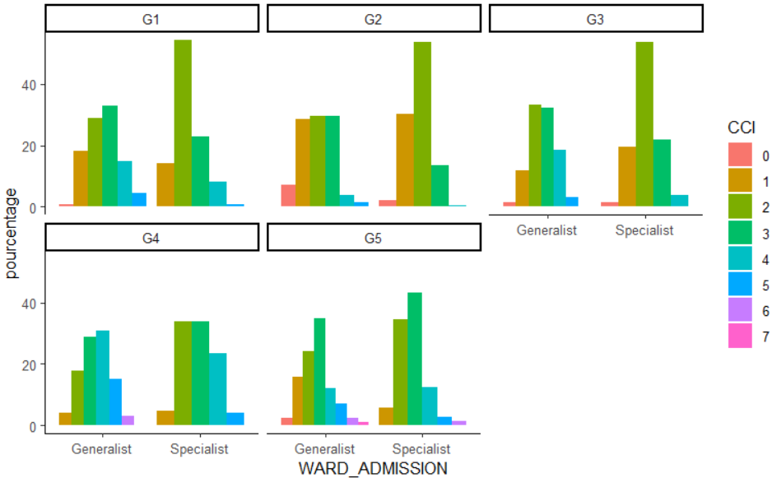

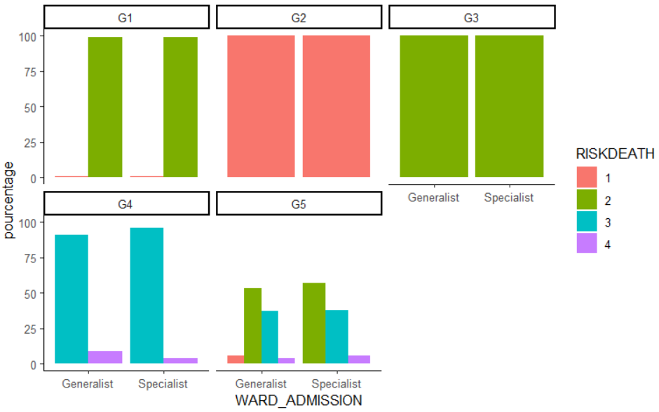
- Nous pouvons remarquer que pour le cas des TOTAL_COST:
- Le groupe G5 regroupe nettement les valeurs les plus élevées de TOTAL_COST, avec une variabilité particulièrement importante et une distribution très asymétrique des données ;
- Avec la plus petite des variabilités, le Groupe G3 semble contenir les valeurs les moins élevées de TOTAL_COST ;
- Les Groupes G2 et G4 sont relativement aux mêmes niveaux en termes de valeurs de TOTAL_COAST, avec une variabilité légèrement plus importante chez G4 ;
- Des valeurs aberrantes peuvent être constatées dans tous les groupes, relativement moins conséquentes et moins élevées en G1, G2, G3 et G4, et plutôt importantes et plus dispersées en G5.
- Nous pouvons remarquer que pour le cas des RISK_DEATH:
- Les groupes G1 et G3 sont principalement et largement constitués d’amissions avec un RISK_DEATH de niveau 2, un type d’admission qui est cependant moins fréquent en G5 ;
- Le Groupe G2 est exceptionnellement constitué d’admission avec un RISK_DEATH 1, un type d’admission qui n’est cependant qu’en très petite quantité en G5;
- Les admissions avec un RISK_DEATH 3 sont très fréquentes en G4, et sont moins fréquentes en G5 ;
- Les admissions avec un RISK_DEATH 4 ne sont que très peu observées en G4 et G5.
- Nous pouvons remarquer que pour le cas des AGE:
- Les Boxplots correspondant aux cinq groupes se trouvent à peu près au même niveau de valeurs d’AGE, avec à peu près une même variabilité et des distributions de données relativement asymétriques.
- Cependant, nous pouvons quand même remarquer que les plus grandes valeurs d’âges sont observées en G4, G1 et G3, et les plus petites à peu près en G5.
- Quelques données aberrantes peuvent être observées en G4.
- Pour le cas des CCI:
- Globalement, chaque groupe est constitué principalement d’admissions avec un indice de CCI 3, puis d’admissions avec un indice de CCI 2.
- Les admissions avec un CCI 1 sont exceptionnellement plus fréquentes en G2 que dans les autres groupes, tandis que pour celles avec un CCI 4, elles sont plus fréquentes en G4 que dans les autres groupes.
- Les admissions avec un CCI 5 ne sont constatées qu’en petites proportions dans les Groupes G5, G4 et G1.
- Les admissions correspondant à un CCI 0 ne sont que très peu rencontrées en G2 ;
- Les admissions correspondant à un CCI 6 ou à un CCI 7 ne sont que très rarement observées en G4 et G5.
- Pour le cas des CCI par rapport aux WARD_ADMISSION:
- En ce qui concerne les Wards Specialist, les pics de proportions sont constituées par les admissions avec un CCI 2 dans G1, G2 et G3, alors que dans G4 et G5, celles avec un CCI 3 semblent prendre le dessus ;
- En ce qui concerne les Wards Generalist, les pics sont constitués par les admissions avec un CCI 3 dans G1, G2 (légèrement) et G5. Dans G3, ce sont celles avec un CCI 2 qui prennent le dessus, tandis que, exceptionnellement, dans G4, ce sont celles avec un CCI 4 qui sont dominantes.
- Les admissions avec un CCI 4 ou 5 constituent des proportions plus ou moins importantes dans les Wards Generalist des Groupe G1, G3, G4 et G5 ; Ce même type d’admissions se rencontre exceptionnellement en bonne proportion dans G4 : Wards Specialists, ce qui n’est pas pourtant un comportement observé au niveau des Wards Specialists des autres groupes ;
- Les admissions avec des CCI 6 et CCI 7 ne se rencontrent que plus ou moins rarement dans les groupes ;
- Les admissions avec un CCI 0 aussi ne se rencontrent que rarement dans les groupes, principalement en G2 : Wards Generalist.
- Pour le cas des RISK_DEATH par rapport aux WARD_ADMISSION:
- Etonnement, les Wards en G2 ne contiennent que des admissions avec un RISK_DEATH de niveau 1, alors que ce type d’admission ne concerne qu’une petite proportion des G5 : Wards Generalist et d’infimes proportions en G1 : Wards Generalists et G1 : Wards Specialists ;
- A nouveau, étonnement, les Wards en G3 ne contiennent que des admissions avec un RISK_DEATH de niveau 2. Un type d’admission qui constitue aussi les pics de proportions en G1 : Wards Generalist et G1 : Wards Specialist, mais aussi en G5 : Wards Generalist et G5 : Wards Specialist
- Les admissions avec un RISK_DEATH de niveau 3 constituent les pics de proportions en G4 : Wards Generalist et G4 : Wards Specialist, et constituent aussi de bonnes proportions des admissions en G5 : Wards Generalist et G5 : Wards Specialist ;
- Les admissions avec un RISK_DEATH de niveau 4 ne se rencontrent que peu fréquemment (G4 : Wards Generalist & G5 : Wards Specialist), rarement (G4 : Wards Specialist & G5 : Wards Generalist), ou même jamais (G1, G2 et G3) au sein des groupes.

